**Package Contents**

1. Admin-server folder
2. Demo(gtog) folder
3. Input folder
4. App setup guide docx

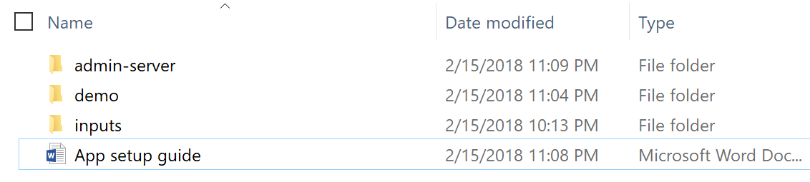

**Running the application – demo(gtog)**

Using maven and cli, move to **demo** folder and execute,

*mvn spring-boot:run*

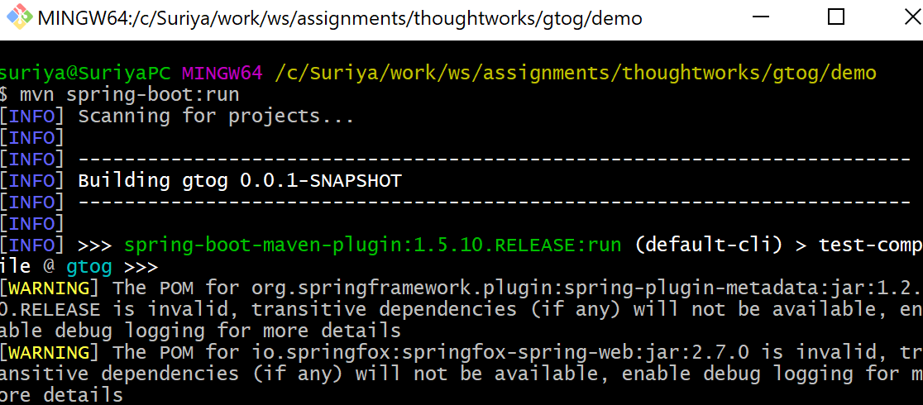

Once the application is started successfully, move to http:localhost:8080/gtog

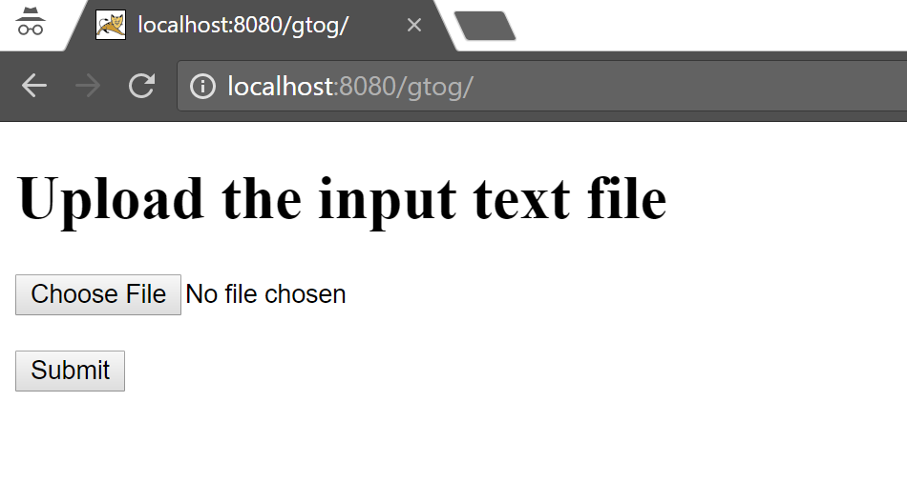

Select a file from **input** folder and open. The application accepts only text files.

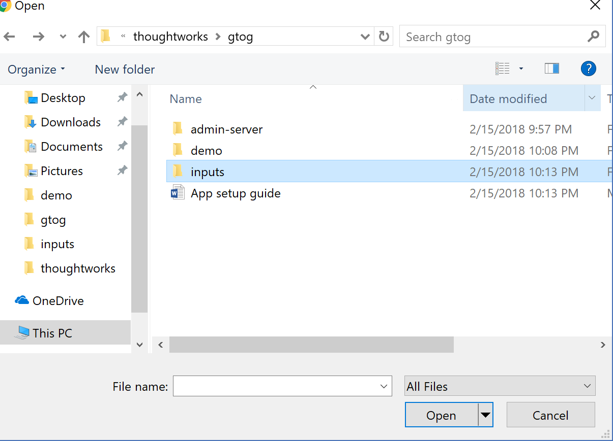

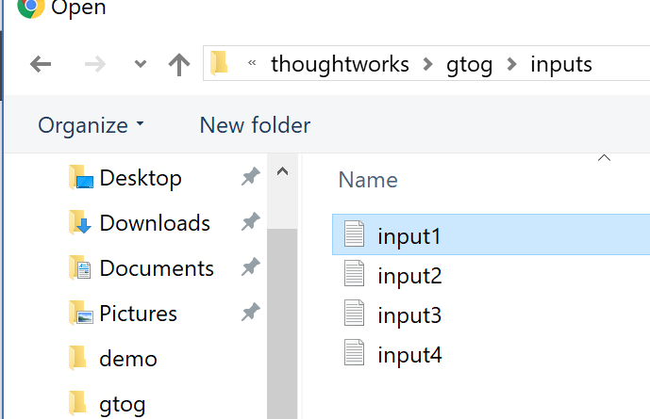

Once submitted,

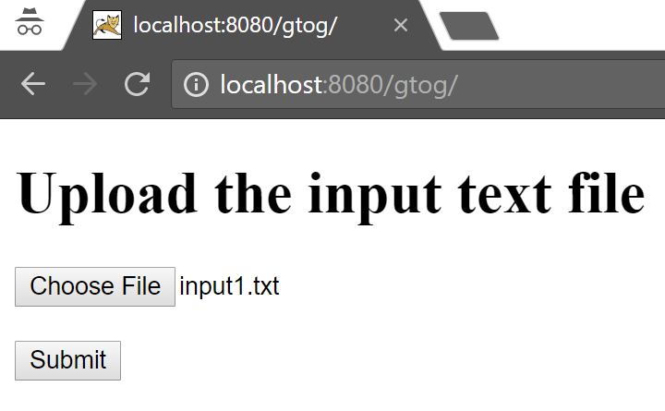

View the result output

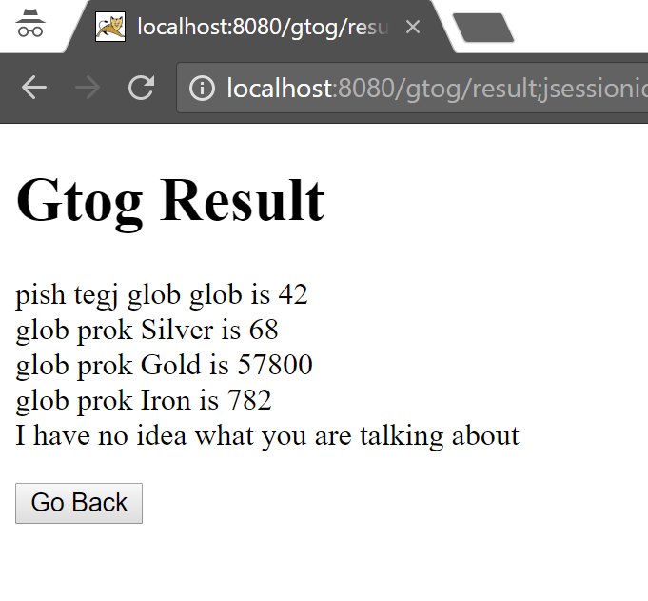

**Running the application – admin server**

Using maven and cli, move to **admin-server** folder and execute,

*mvn spring-boot:run*

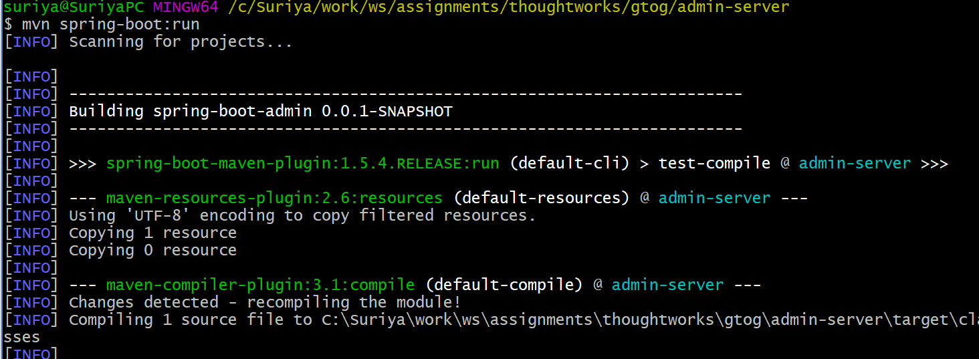

Once the app is started at port 1111 and the client gets registerd, open browser and goto <http://localhost:1111>

Login into the admin page, with “admin” and “secret”

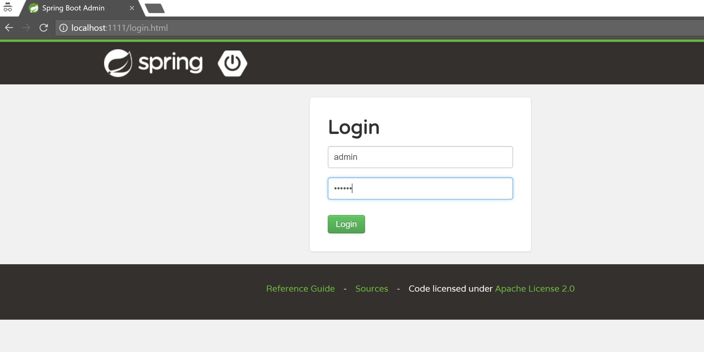

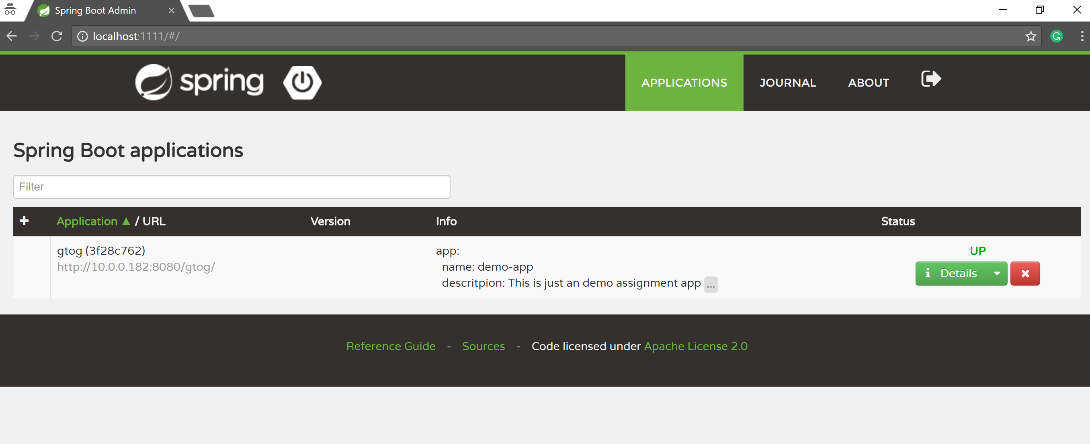

To application management endpoints click on details,

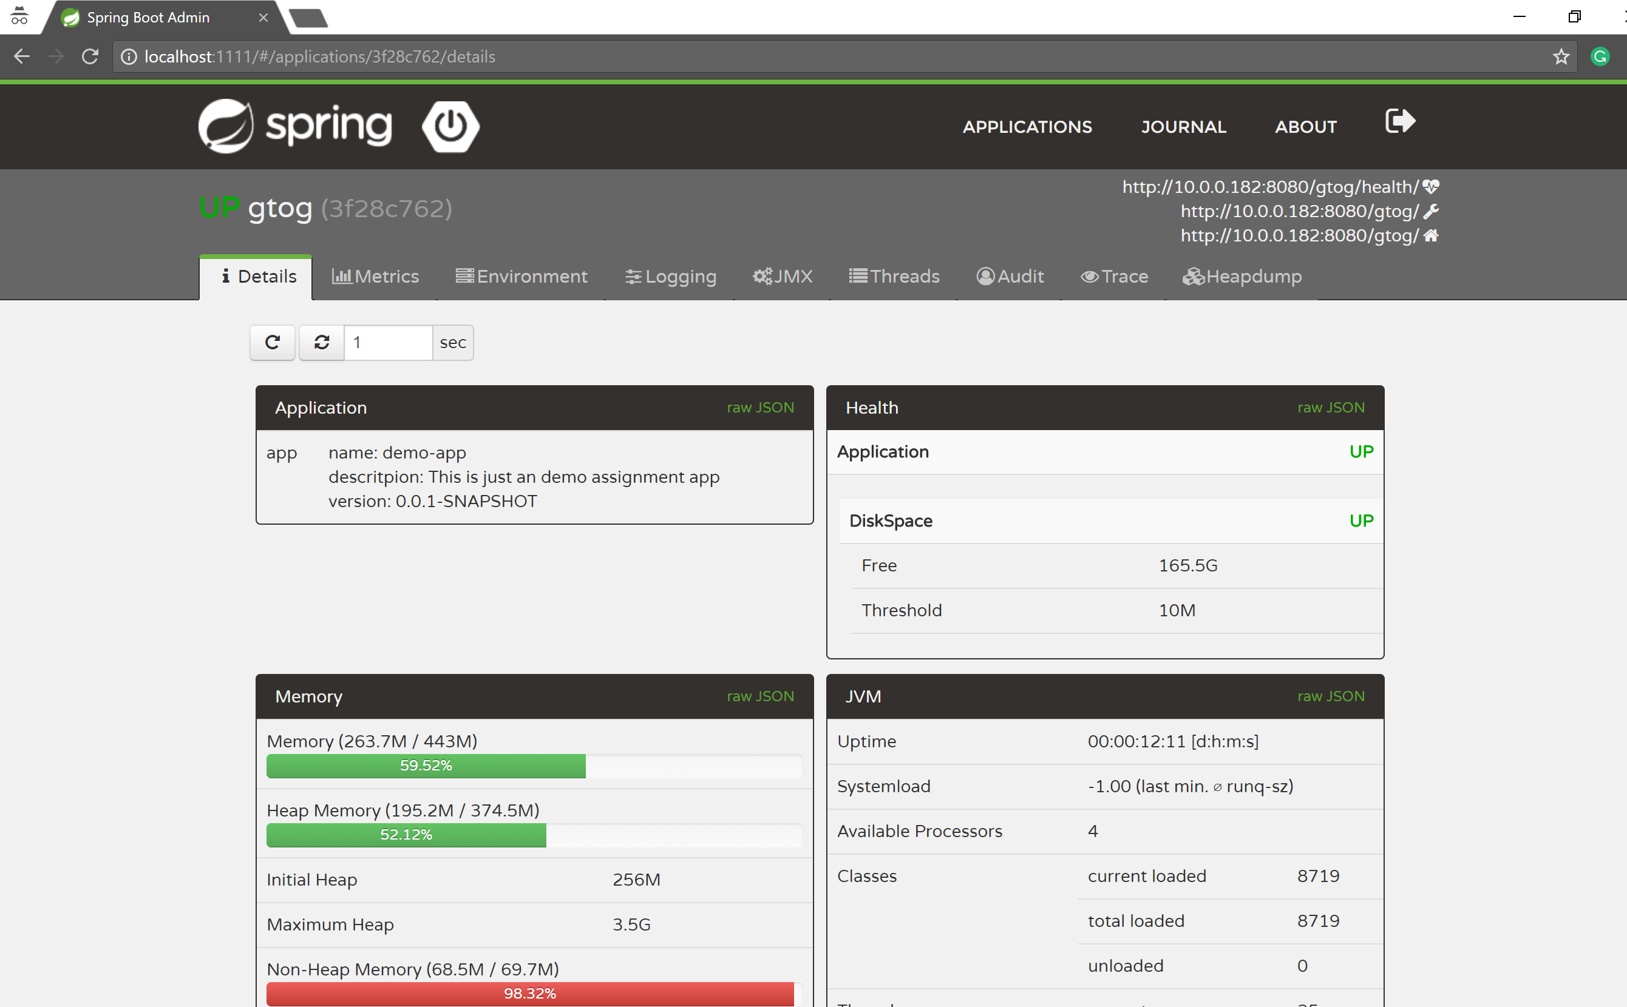

**Running the application in docker – demo(Gtog)**

Make sure the port 8080 is free,

Using docker CLI, move to **demo** folder and run,

*mvn clean package*

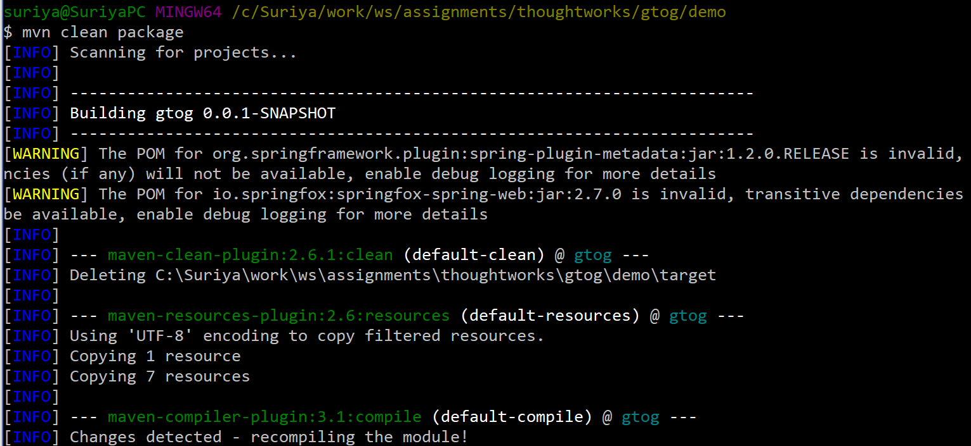

Once the project is built successfully,

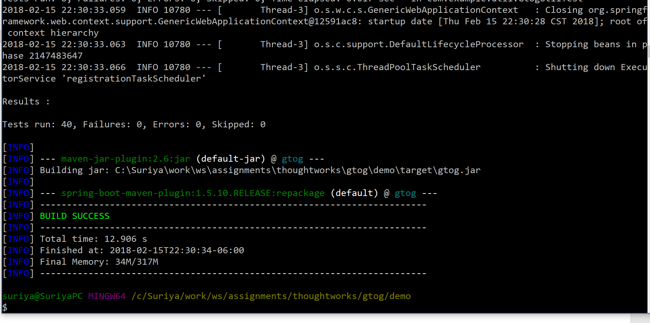

Run the following command,

*docker build -t gtog .*

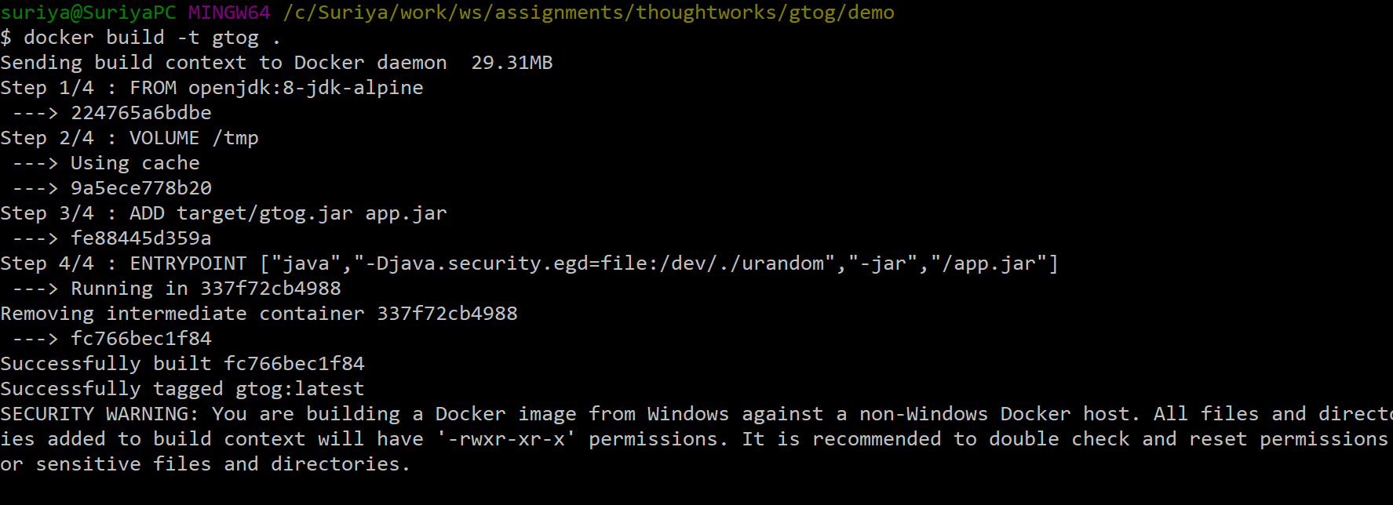

Once the image is successfully built run,

*docker run -p 8080:8080 gtog*

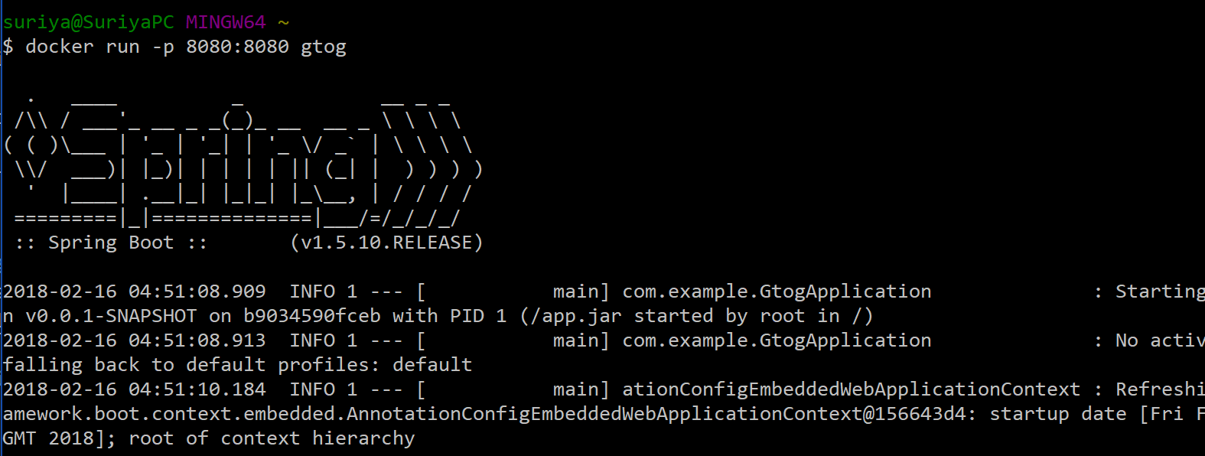

While running in docker container, as it is not configured to access spring boot admin, gtog demo application will not register with admin.

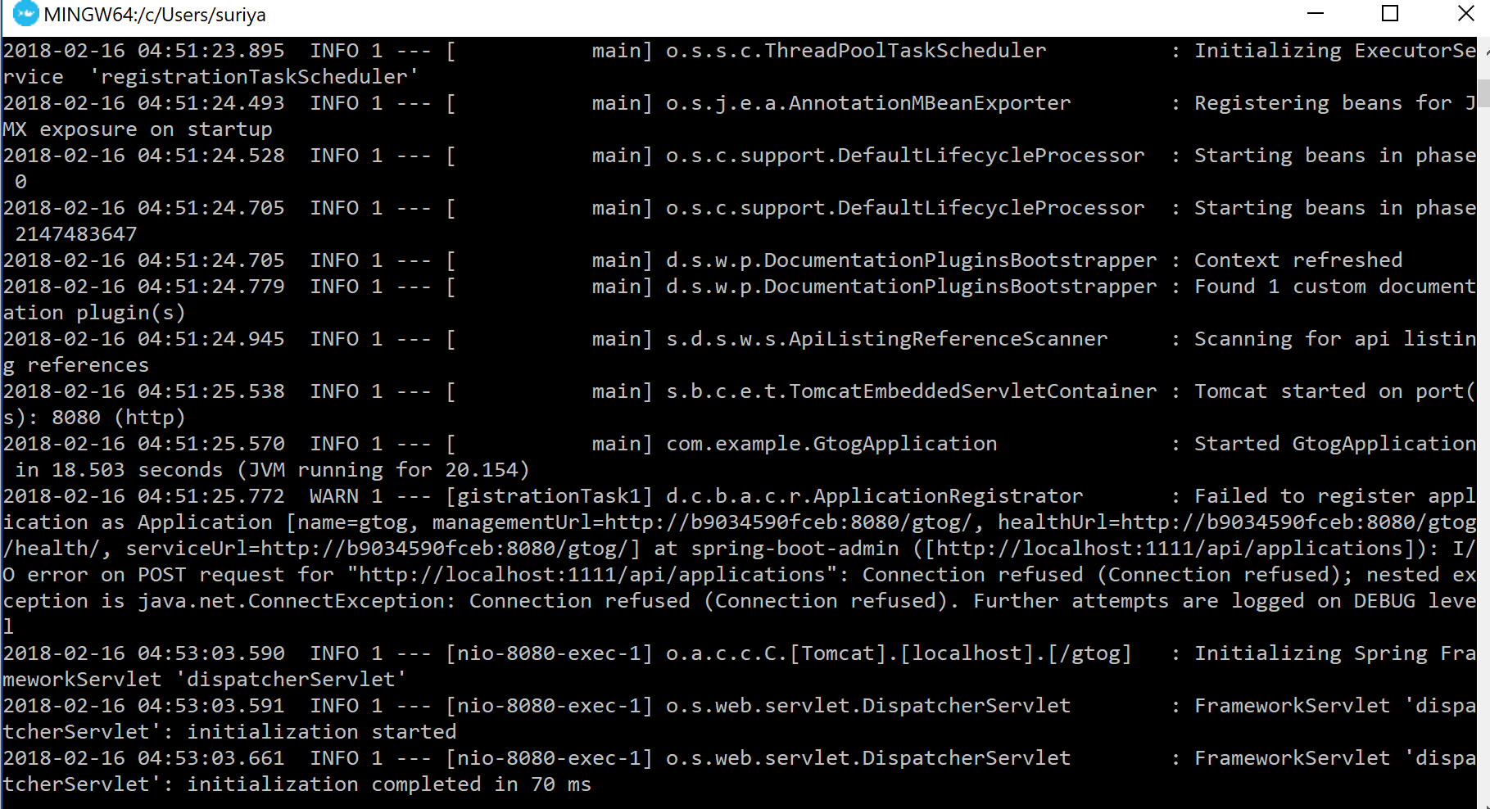

Once the application has started, goto

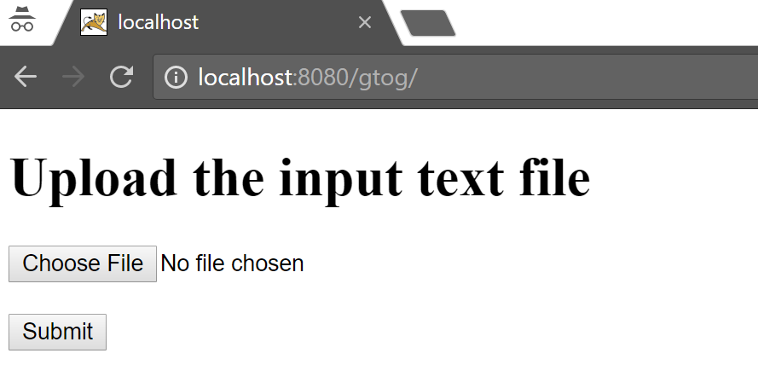

This is running in the docker container.

